## Create a class Circle which represent a real circle object with the data

Radius – double type

Color – string type

Include three types of Constructors in the class.

### Create three different object with the help of three constructors defined in the class

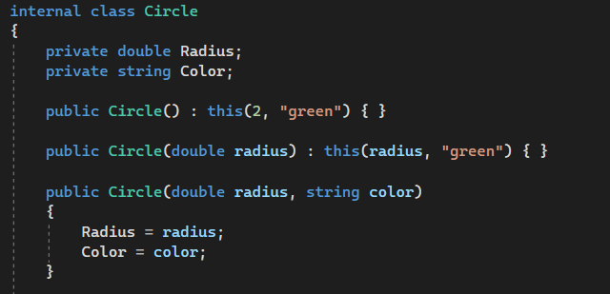

### Add methods getRadius() and getColor() to return the radius and color respectively

public double getRadius()

{

return Radius;

}

public string getColor()

{

return Color;

}

### Add methods setRadius(double d) and setColor(String c) to set the value of radius and color respectively.

public void setRadius(double radius)

{

Radius = radius;

}

public void setColor(string color)

{

Color = color;

}

### Test the class in main method.

Circle circle = new Circle();

Console.WriteLine("Circle 1: Radius = " + circle.getRadius() + ", Color = " + circle.getColor());

circle = new Circle(4.0);

Console.WriteLine("Circle : Radius = " + circle.getRadius() + ", Color = " + circle.getColor());

circle = new Circle(6.0, "blue");

Console.WriteLine("Circle : Radius = " + circle.getRadius() + ", Color = " + circle.getColor());

circle.setRadius(3);

circle.setColor("Orange");

Console.WriteLine("update Circle : Radius = " + circle.getRadius() + ", Color = " + circle.getColor());

## Define a class Holiday which representing holidays during the year.

There is three instance variables

Name – String, name of the holiday

Day – int, day of the month of the holiday

Month - string, the month in which the holiday in.

### Define parametrized constructor

public Holiday(string name, int day, string month)

{

Name = name;

Day = day;

Month = month;

}

### Define method InSameMonth() – compare two instance of the class Holiday and returns the Boolean value “true” if they have same month and “false” if they do not.

public bool InSameMonth(Holiday other)

{

return Month == other.Month;

}

### Define a method to display the holiday details as Day: 26 Month : January Description : today is republic day

public void DisplayHolidayDetails()

{

Console.WriteLine($"Day: {Day} Month: {Month} Name: {Name}");

}

### Create Holiday instance as array to store holidays in a month and test the class

Holiday[] holidays = new Holiday[3];

holidays[0] = new Holiday("May Day", 1, "May");

holidays[1] = new Holiday("New Year", 1, "January");

holidays[2] = new Holiday("Republic Day", 26, "January");

Console.WriteLine("Are Republic Day and NEW YEAR in the same month? " + holidays[2].InSameMonth(holidays[1]));

Console.WriteLine("Holiday Details:");

foreach (var holiday in holidays)

{

holiday.DisplayHolidayDetails();

Console.WriteLine();

}

## Given the structure of two classes. Implement the given inheritance and test the class. Methods and its return types are specified in the diagram. toString() method both in the class will display the value of its data members.

